Hi Herbs Product Catalog
Organized by Product Category

1. Oils
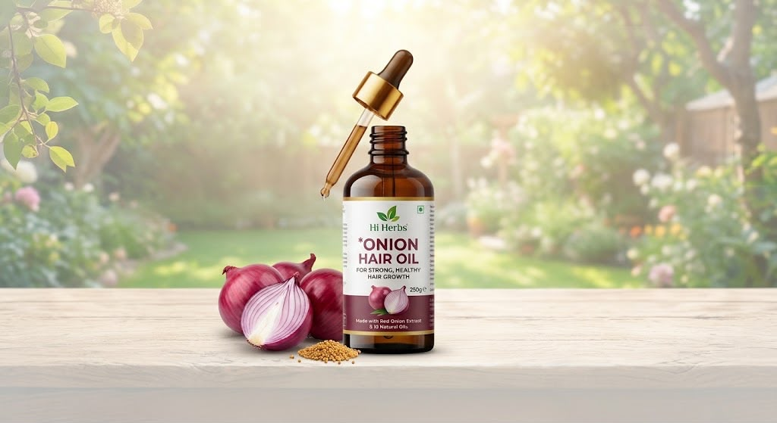
Onion Hair Oil
Rs 250/30ml
For strong, healthy hair growth — made with red onion extract & 10 natural oils.
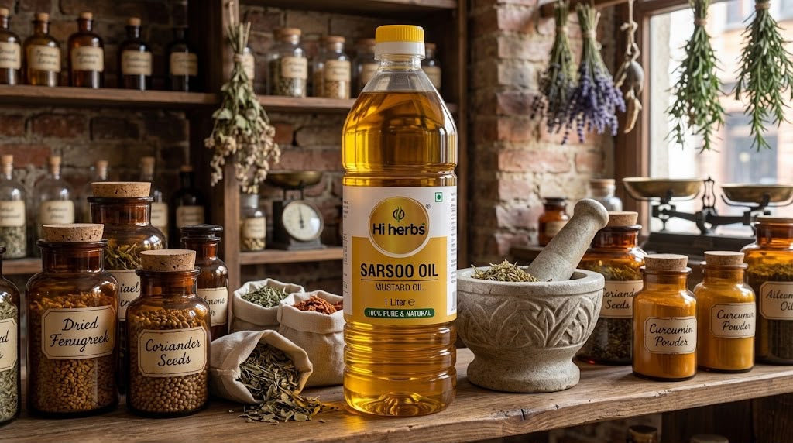
Sarsoo Oil (Mustard Oil)
Rs 600/ 1 litre
100% pure & natural mustard oil, 1 litre.
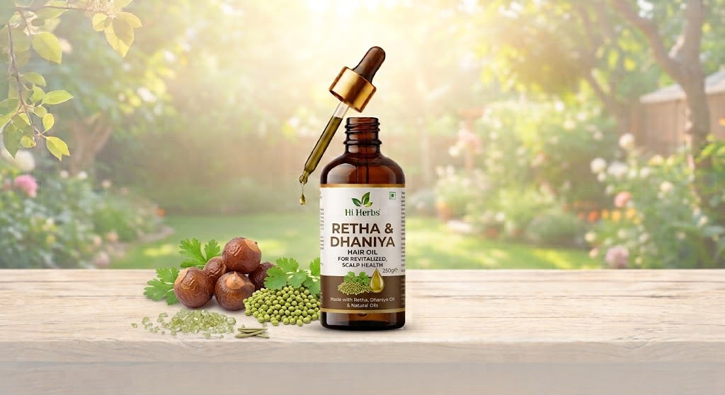
Retha & Dhaniya Hair Oil
Rs 300/ 250 gms
For revitalized scalp health — made with retha, dhaniya oil & natural oils, 250g.
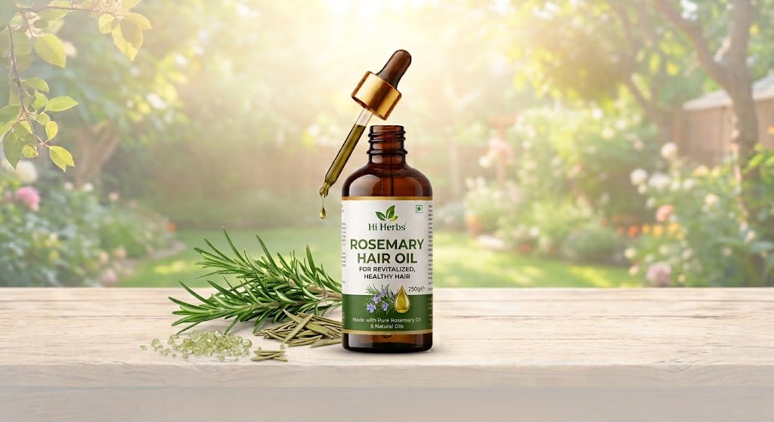
Rosemary Hair Oil
Rs 120/ 50gms
For revitalized, healthy hair — made with pure rosemary oil & natural oils, 50g.
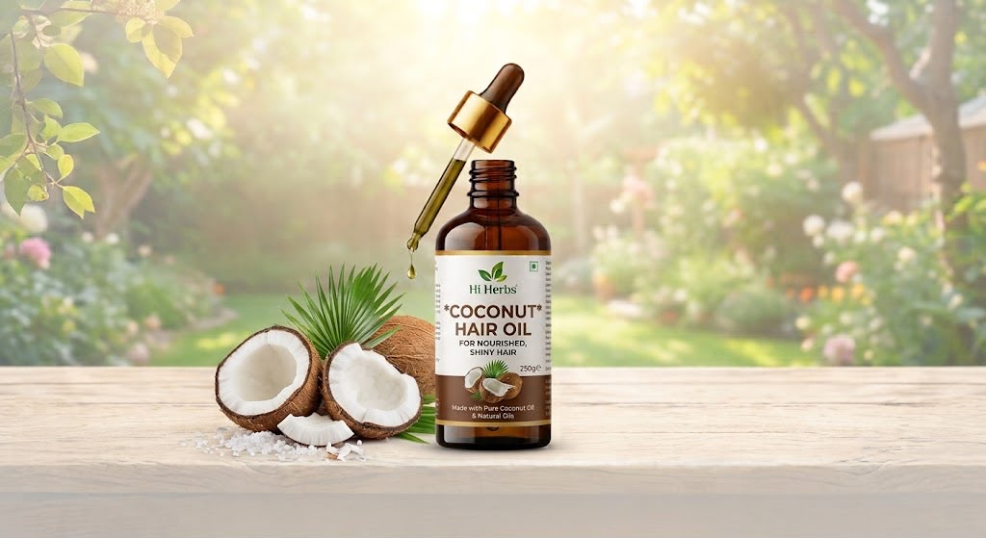
Coconut Hair Oil
Rs 400/ 250gms
For nourished, shiny hair — made with pure coconut oil & natural oils, 250g.
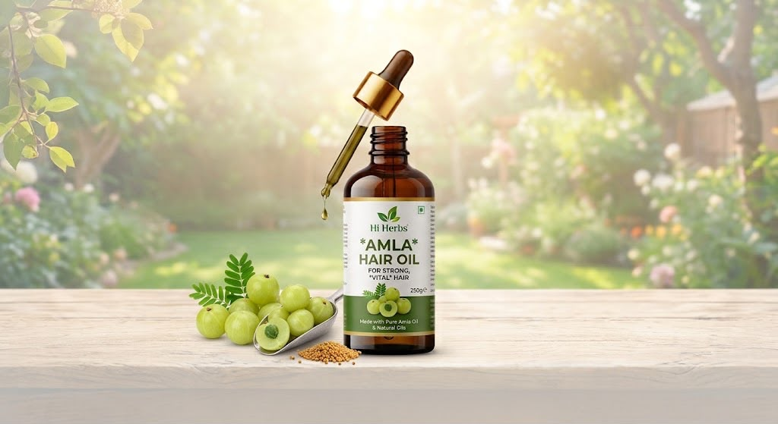
Amla Hair Oil
Rs 300/ 250gms

For strong, vital hair — made with pure amla oil & natural oils, 250g.
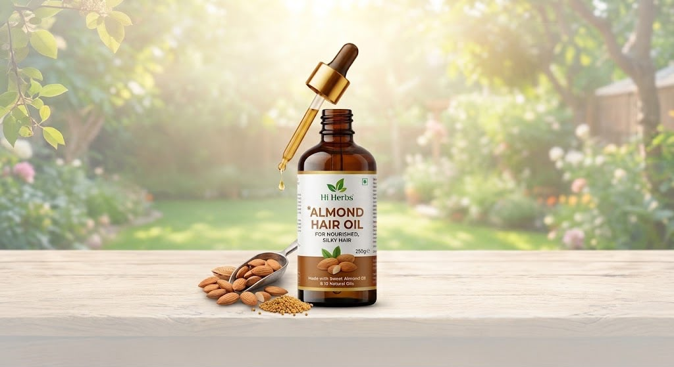
Almond Hair Oil
Rs 250/ 50gms
For nourished, silky hair — made with sweet almond oil & 10 natural oils.

2. Skin Care
Rose Water Spray
Natural, refreshing rose water toning spray for daily skin care.
(No product image was included in the uploaded files — placeholder entry.)

3. Hair Care
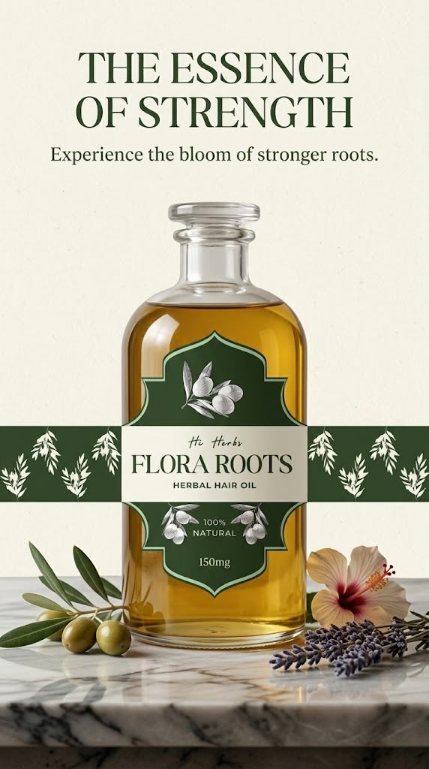
Flora Roots Herbal Hair Oil
Rs 699/ 150ml
"The Essence of Strength" — 100% natural herbal hair oil, 150mg, for stronger roots.
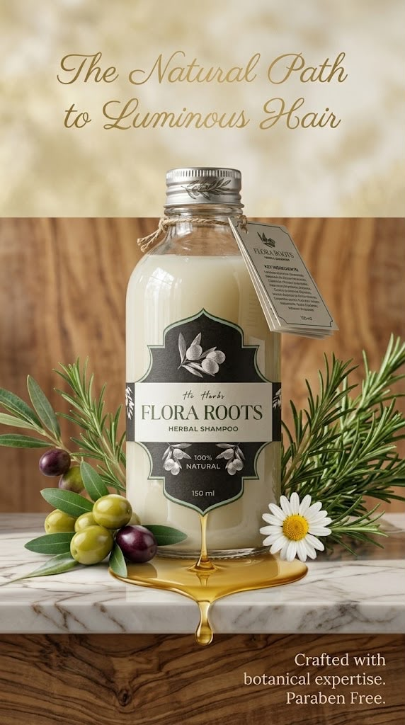
Flora Roots Herbal Shampoo
Rs 250/ 150ml

"The Natural Path to Luminous Hair" — 100% natural, paraben-free herbal shampoo, 150ml.

4. Other Product Categories

Men's Fertility Health
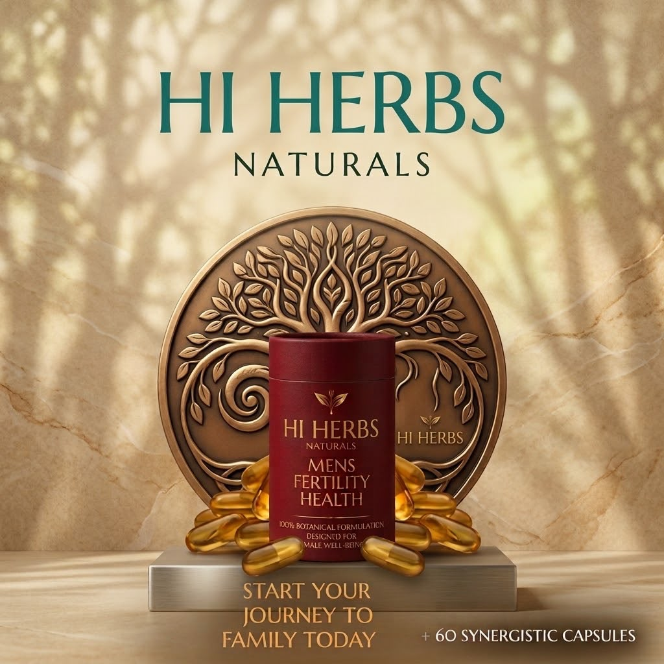
Hi Herbs Naturals — Men's Fertility Health
Rs 1000/ 100gms
100% botanical formulation designed for male well-being. Start your journey to family today. +60 synergistic capsules.

Diabetes Support
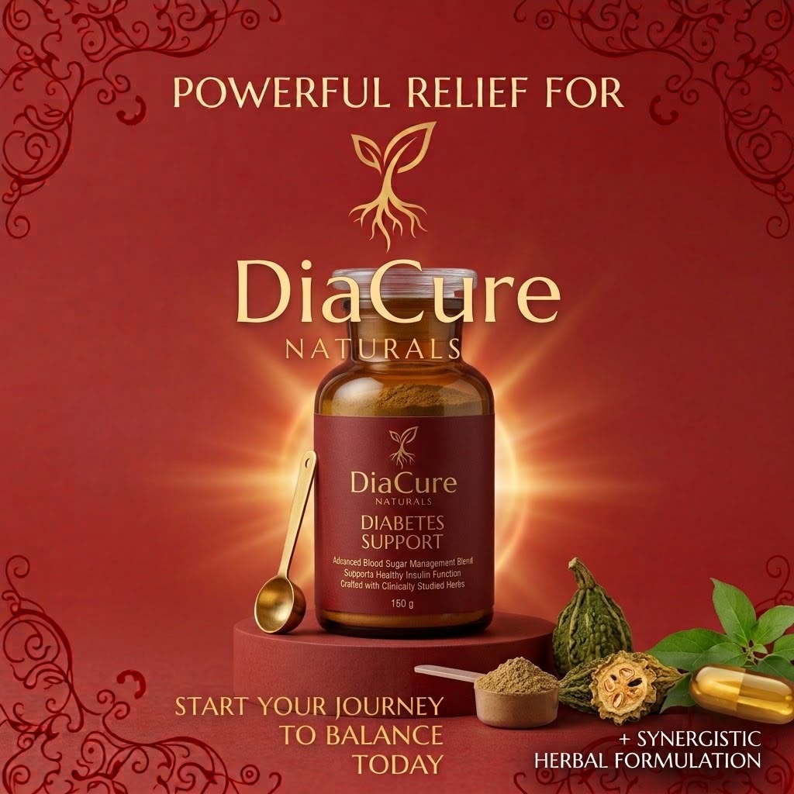
DiaCure Naturals — Diabetes Support
Rs500/ 60 capsules
Advanced blood sugar management blend, supports healthy insulin function, crafted with clinically studied herbs.

Kids' Growth Nutrition
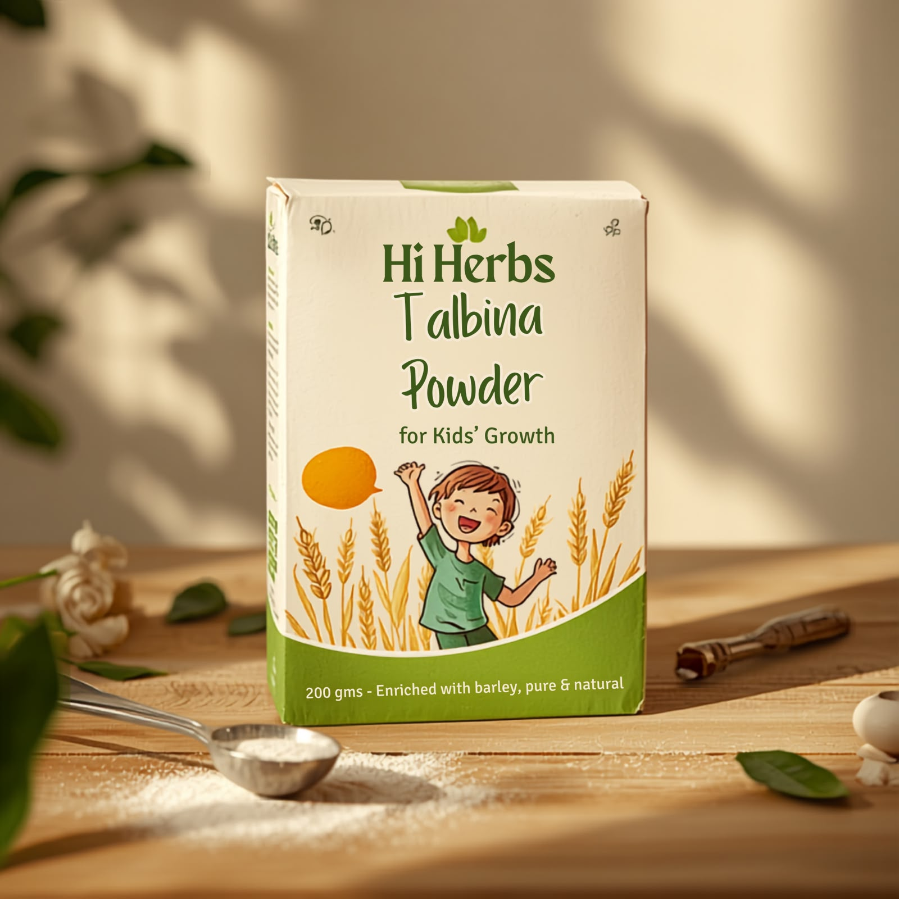
Hi Herbs Talbina Powder
Rs 1000/ 500gms
For kids' growth — enriched with barley, pure & natural, 200g.

Acidity & Reflux Relief (AciCalm)
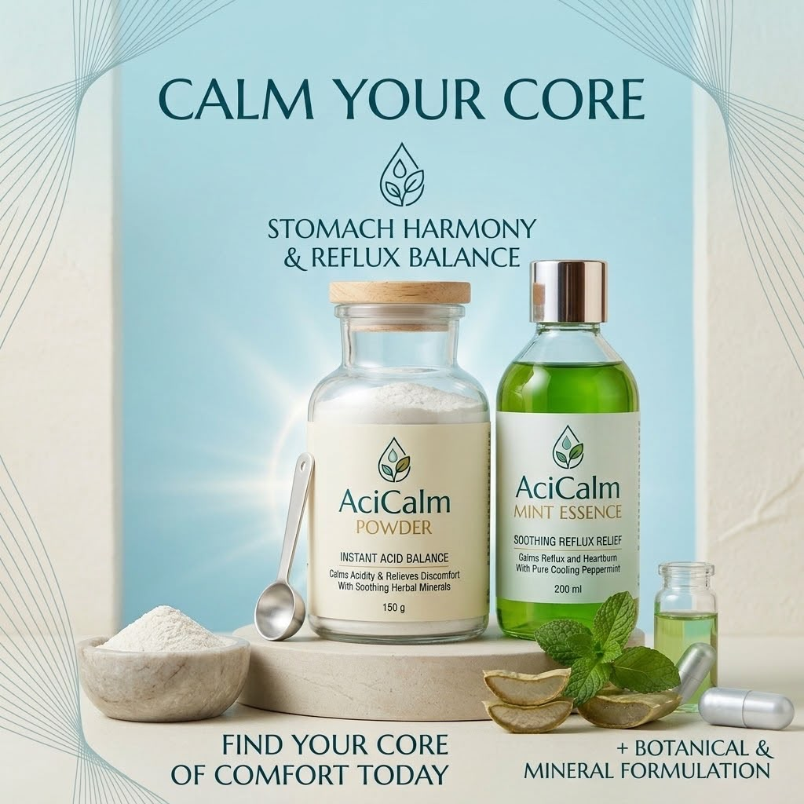
AciCalm Powder & Mint Essence
Rs 200/ AciCalm
Rs 200/ Mint Essence
Stomach harmony & reflux balance. Powder calms acidity & relieves discomfort with soothing herbal minerals (150g). Mint Essence soothes reflux & heartburn with pure cooling peppermint (100g).
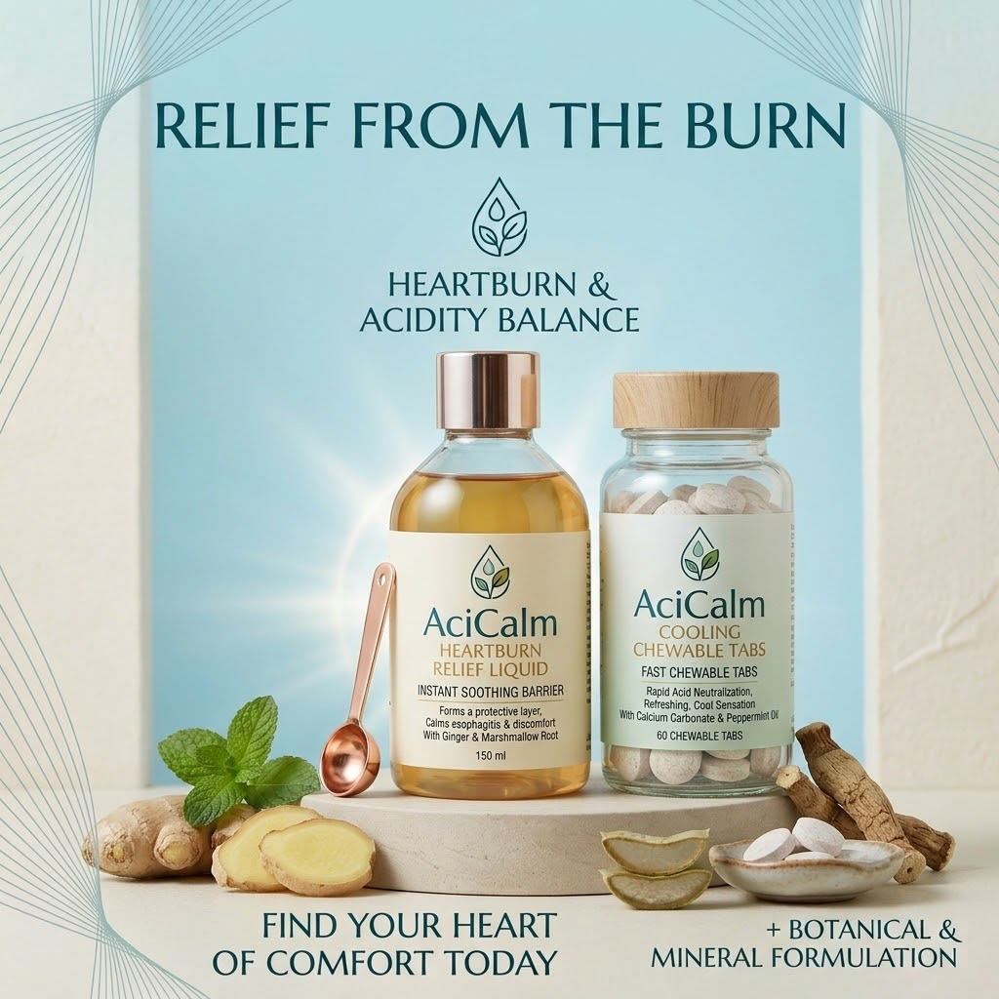
AciCalm Heartburn Relief Liquid & Cooling Chewable Tabs
Rs 150/ AciCalm Heartburn Relief Liquid
Rs 200/ Cooling Chewable Tabs

Heartburn & acidity balance. Relief Liquid forms a protective soothing barrier with ginger & marshmallow root (150ml). Cooling Chewable Tabs give rapid acid neutralization with calcium carbonate & peppermint oil (60 tabs).

Herbal Weight Gain
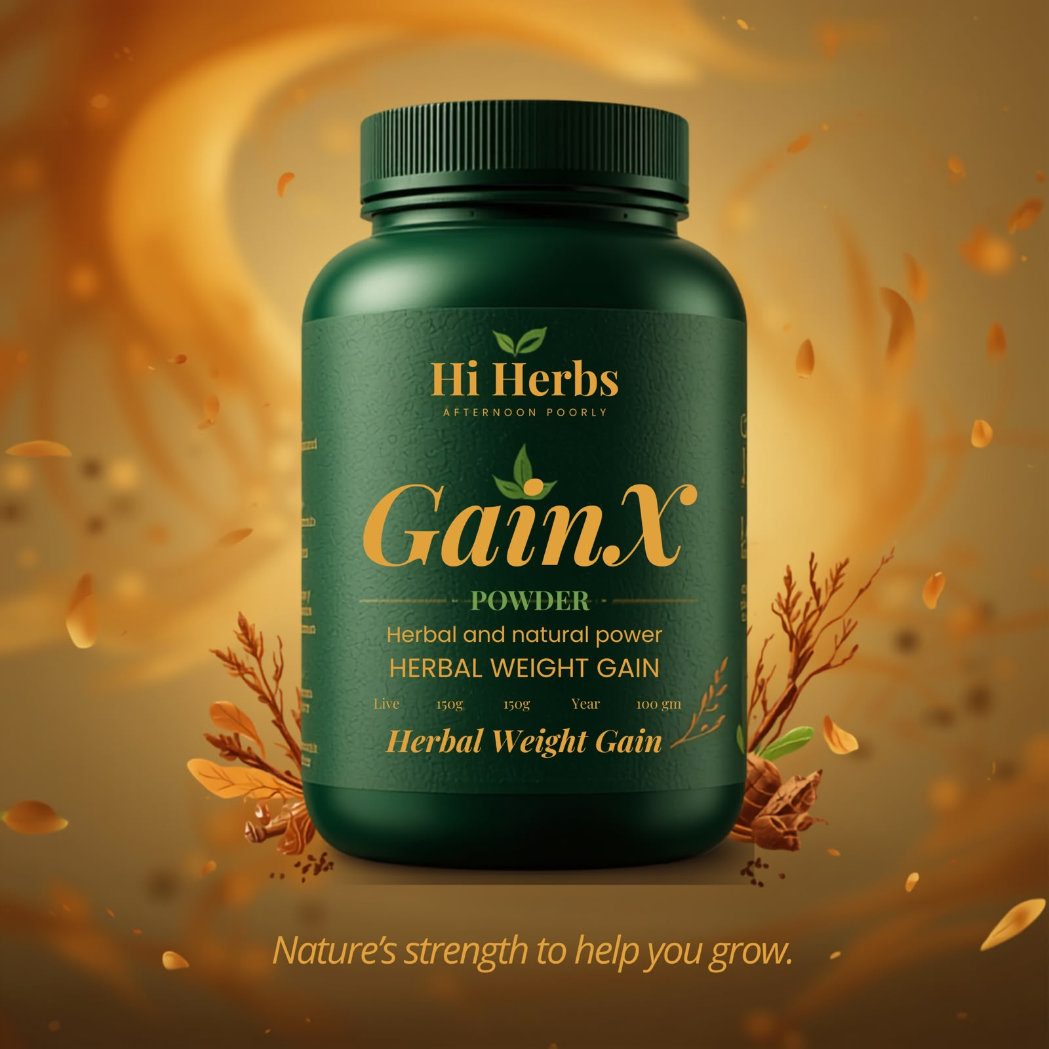
Hi Herbs GainX Powder
Rs1000/ one month
guaranteed result
Herbal and natural power for herbal weight gain. Nature's strength to help you grow.

Joint & Muscle Pain Relief — PainRoot
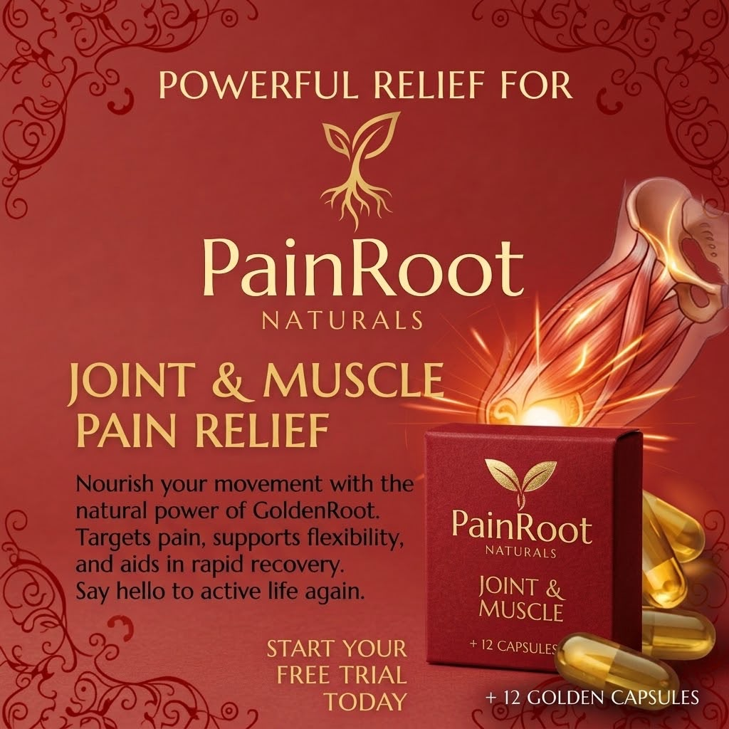
PainRoot Naturals — Joint & Muscle
Rs 200/-
Nourishes movement with the natural power of GoldenRoot. Targets pain, supports flexibility, aids rapid recovery. +12 golden capsules.

Weight Loss (Trim & Tone)
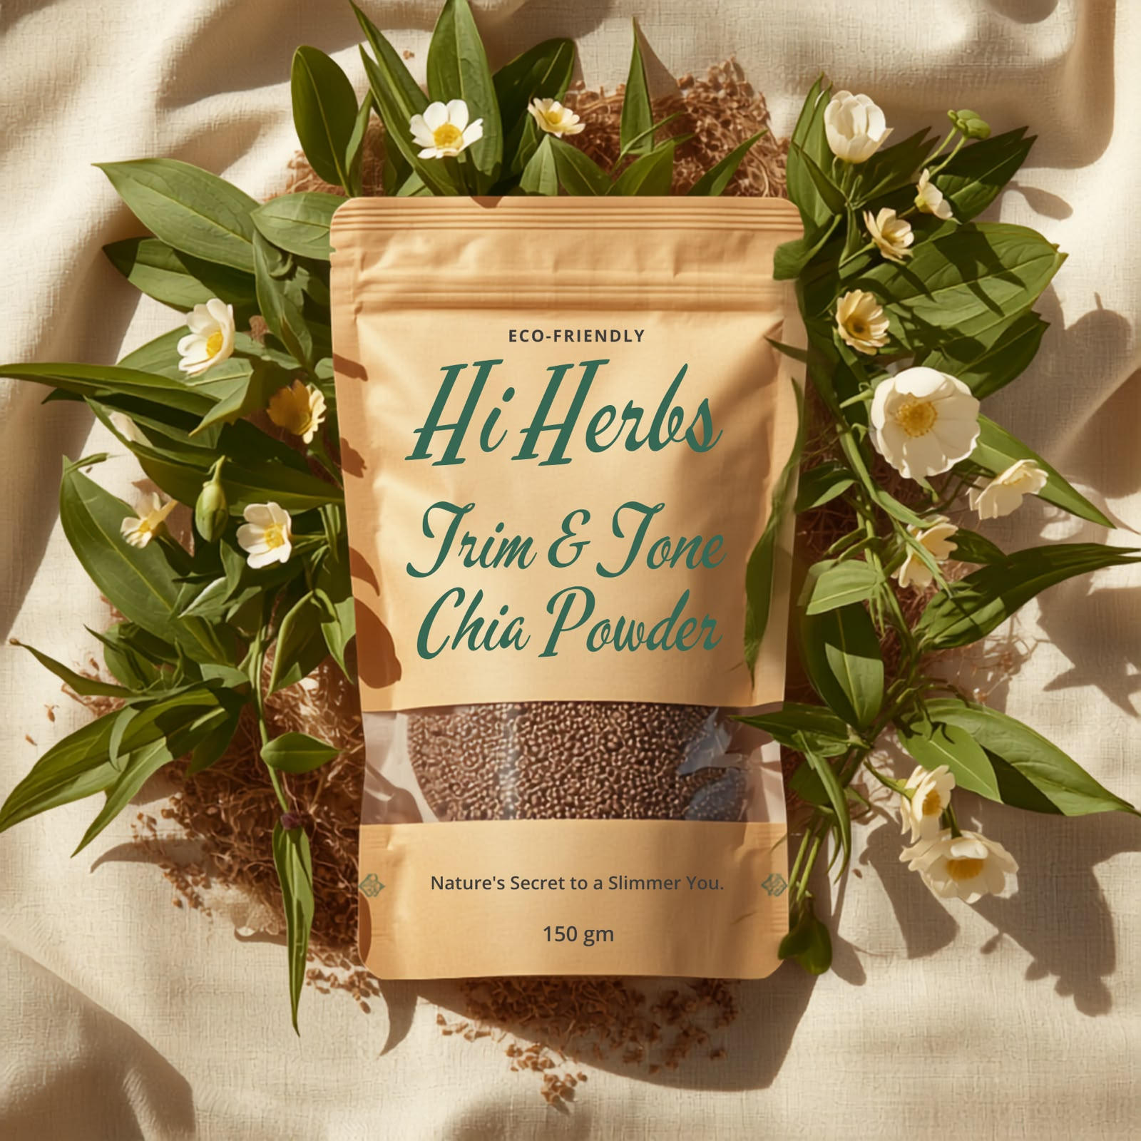
Hi Herbs Trim & Tone Chia Powder
Rs 400/ 250gm

Nature's secret to a slimmer you — eco-friendly.

Women's Health
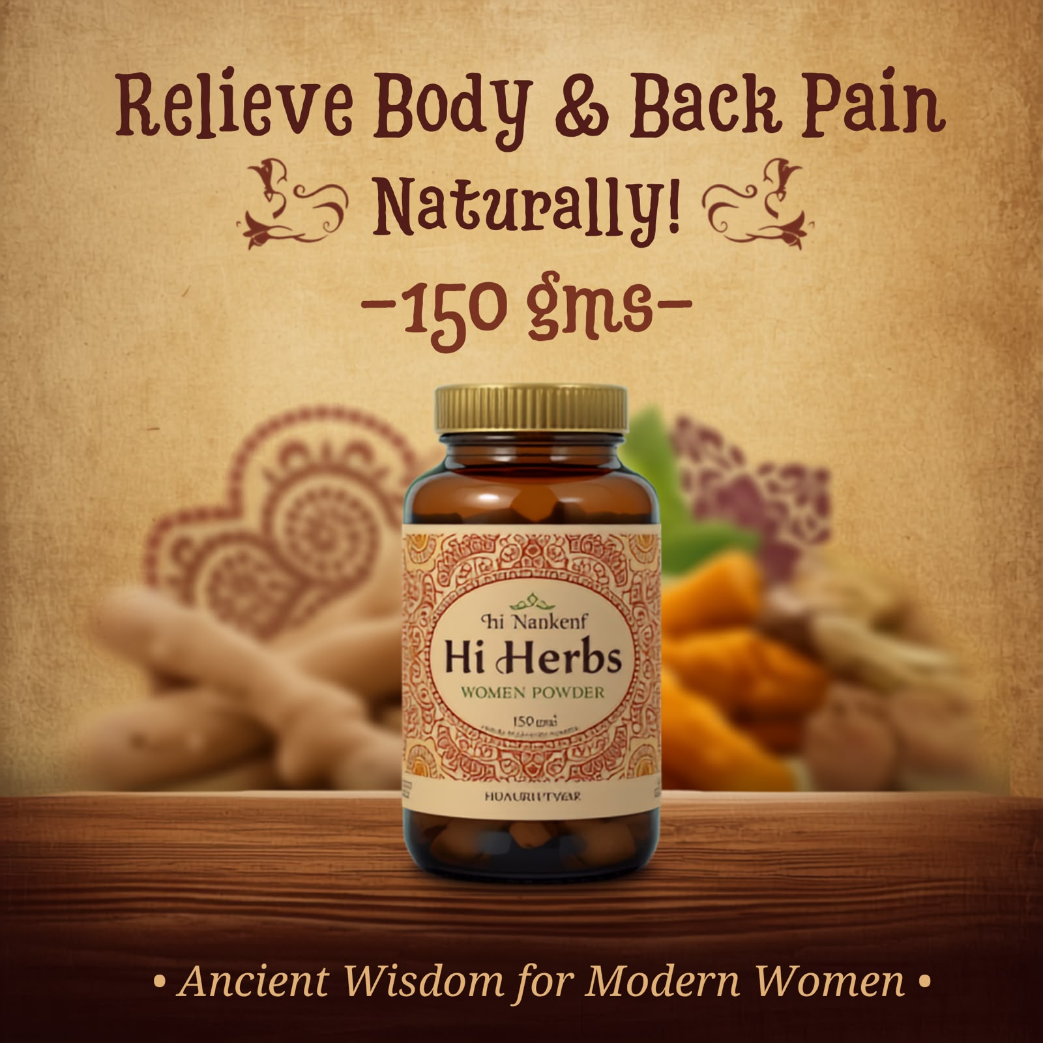
Hi Herbs Women Powder
Rs 1000
Relieve body & back pain naturally! Ancient wisdom for modern women, 150g.

